**Lab – 42: How to customize the Microsoft Intune Company Portal app?**

**Objective:** The objective of this lab is –

* To customize the Microsoft Intune Company Portal app using Microsoft Intune Classic Portal.

The Microsoft Intune company portal is where users access company data and can do common tasks like enrolling devices, installing apps, and locating information for assistance from your IT department. Customizing the Company Portal helps provide a familiar and helpful experience for your end users. So, in this lab we are going to customize the company portal.

**Prerequisite:** EMS Enterprise Mobility + Security E5.

**Steps:**

1. Sign in to your Microsoft Intune classic portal, by using the link - **https://admin.manage.microsoft.com/**. Enter your credentials and click **Sign In**.

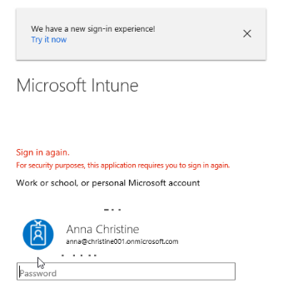

1. Microsoft Intune Dashboard will open.

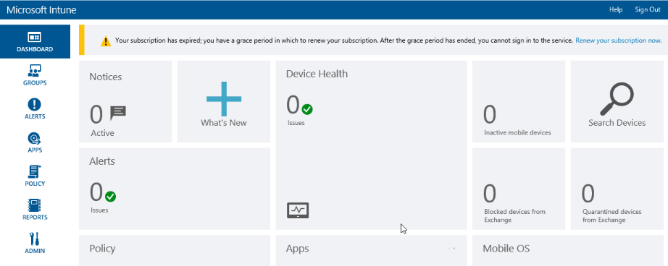

1. Go to **Admin**, then click **Company Portal** under Mobile Device Management.

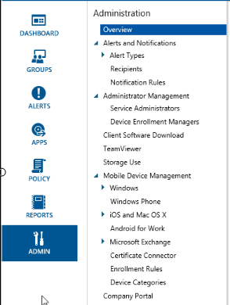

1. Company portal customization options will open. From here, you can specify company name, company contact information and privacy statement. The company name is displayed as the Company Portal title. The contact information and details are displayed to users in the Contact IT screen of the Company Portal. The privacy statement is displayed when a user clicks on the privacy link.

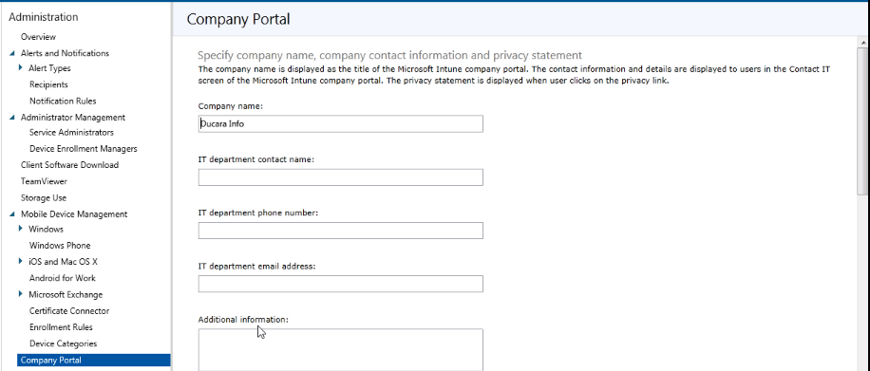

1. Enter the details –

**Company name:** This name is displayed as the title of the Company Portal.

**IT department contact name:** This name is displayed on the Contact IT page.

**IT department phone number:** This contact number is displayed on the Contact IT page.

**IT department email address:** This contact address is displayed on the Contact IT page. You must enter a valid email address in the format alias@domainname.com.

**Additional information:** Displayed on the Contact IT page.

**Company privacy statement URL:** You can specify your own company privacy statement that appears when users click the privacy links from the Company Portal. You must enter a valid URL in the format https://www.example.com.

**Then specify a website that users can contact for support.**

**Support website URL**: If you have a support website that you want your users to use, specify the URL here. The URL must be in the format https://www.contoso.com. If you don't specify a URL, nothing is displayed for the support website on the Contact IT page in the Company Portal.

**Support website name:** This name is the friendly name that is displayed for the URL to the support website. If you specify a support website URL and no friendly name, then Go to IT website is displayed on the Contact IT page in the Company Portal.

**Then enter company branding customization.**

**Theme color**: Select a theme color to apply to the Company Portal.

**Show company logo**: When you enable this option, you can upload your company logo to show in your Company Portal. You can upload two logos: one logo that is displayed when the Company Portal background is white, and one logo that is displayed when the Company Portal background uses your selected theme color. Each logo must be a .png or .jpg file type and have a maximum resolution of 400 x 100 pixels and be 750 KB or less in size. By using this option, you can also show the company name you entered next to the uploaded logo.

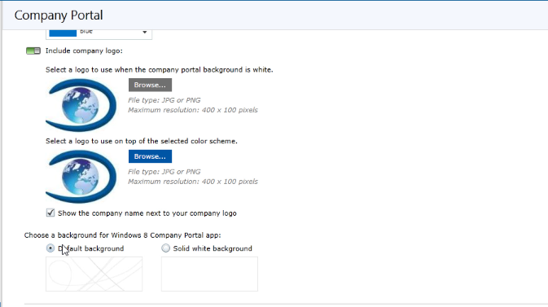

1. Then click **Save**.
2. After saving, open Company Portal app and you can see the changes has been made what you have customized.

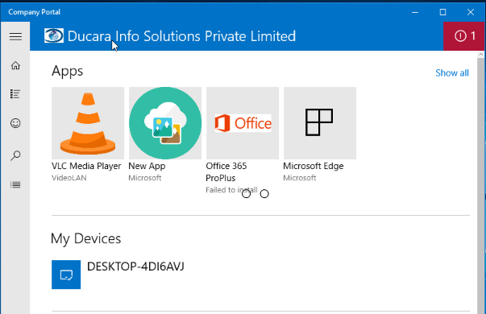

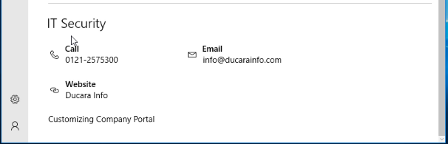

1. So, in this way you can customize the Intune Company Portal using Microsoft Intune Classic Portal.